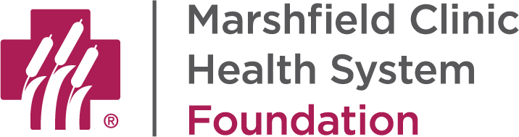

INFORMATION FOR DONORS AND ADVISORS

Legal Name: Marshfield Clinic Health System Foundation, Inc.

Tax Identification Number: 81-2822823

Tax Exempt Status: Marshfield Clinic Health System Foundation, Inc. was granted tax-exempt status by the Internal Revenue Service under Internal Revenue Code Section 501(c)(3) as of June 2, 2016. The Foundation is a public charity under Section 170(b)(1)(A)(vi). A copy of the determination letter can be obtained by contacting the Marshfield Clinic Health System Foundation.

Contact Information:
Address: MCHS Foundation
1000 North Oak Avenue, 1R1
Marshfield, WI 54449

Phone: (715)387-9249 or (800)858-8220

Website: www.marshfieldclinic.org/giving

Email: giving@marshfieldclinic.org

Gift Information:
Cash: Please make checks payable to Marshfield Clinic Health System Foundation or MCHS Foundation and mail to the address above.

Credit Card: Credit card gifts may be made online at www.marshfieldclinic.org/giving/donate or by contacting the Foundation office during regular business hours.

Securities: Securities may be transferred via DTC. Contact the Foundation for DTC instructions. DTC instructions are also available online at www.marshfieldclinic.org/giving/gifts-of-stock. Please contact the Foundation for gifts of securities held in certificate form.

Estate gifts: Please use the following sample language as a guide for gifts by will, trust or beneficiary designation:
“I give $10,000 to Marshfield Clinic Health System Foundation, Inc., Tax Id Number 81-2822823, 1000 North Oak Avenue, Marshfield, WI 54449 to be used for cancer research.”
Additional information is available by contacting the Foundation or by visiting www.marshfieldclinic.org/legacy.

